MSCI 433 Assignment 4

Q1:

Q1.a.i ) The reason it will take a large amount of time to build a hierarchal clustering model is due to the fact that we have a large amount of observations which will be to great for a hierarchal cluster model.

Q1.a.ii) I would recommend a cluster size of 6 because you would like to not overwhelm the reader too many category recommendations.

Q1.a.iii)

Each cluster has the following number of observations

|  |  |
| --- | --- |
| Cluster | # of observations |
| 1 | 2220 |
| 2 | 436 |
| 3 | 324 |
| 4 | 166 |
| 5 | 228 |
| 6 | 56 |

Q1.a.iv) Description of each cluster

Cluster 1:

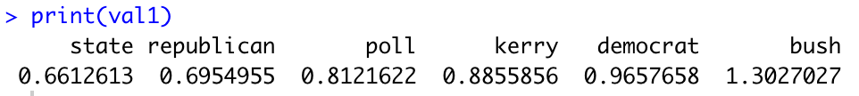

Cluster 2:

Cluster 3:

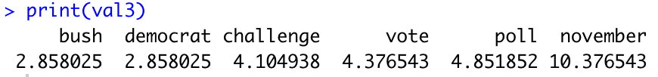

Cluster 4:

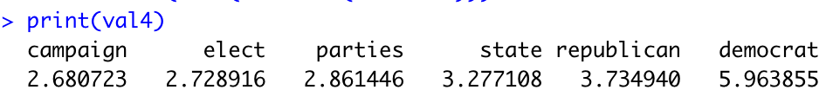

Cluster 5:

Cluster6:

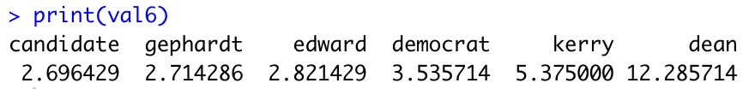

Q1.b)

Q1.b.i) The answer is not exactly the same as in hierarchal clustering.

Q1.b.ii)

The clusters that are the same across the 2 models are:

Kmcluster 1:

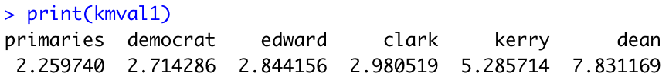

Kmcluster2:

Kmcluster3:

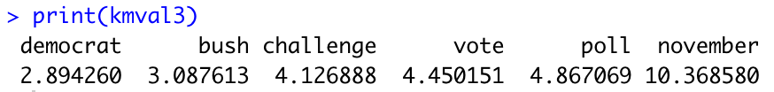

Kmcluster4:

Kmcluster5:

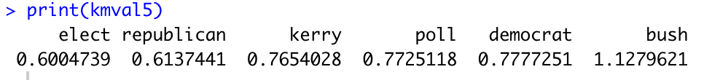

Kmcluster6:

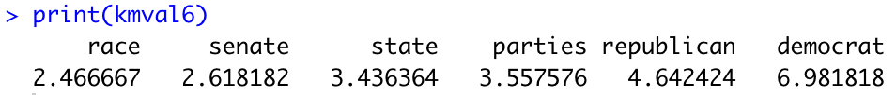

Q1.c)

The results

Using 4 clusters in hierarchical clustering

|  |  |
| --- | --- |
| Cluster | # of observations |
| 1 | 2448 |
| 2 | 436 |
| 3 | 324 |
| 4 | 222 |

Using 4 clusters in kmeans clustering

#############################################################################

Q2)

Q2.a.i) The reason it is important to normalize data in

Q2.a.ii)

Q2.b.i)

Q2.b.ii)

Q2.b.iii)

Q2.b.iv)

Q2.c.i)

Q2.c.ii)

Q2.c.iii)

#############################################################################

Q3)

Q3.a)

Q3.a.i) The age bracket with the most is 20-24, while the age bracket with the least is 60-65

Default histogram

Histogram with binwidht=5

Q3.a.ii) The argument color blue adds a blue outline to the histogram bars

Histogram with binwidht=5 and colour blue



Q3.b.i) The insights gained from this data is on average there are more males than females in respective age brackets.

Q3.b.ii) This argument makes the histograms appear side by side



Q3.b.iii)



Q3.c)



Q3.c.i) The most common time served is from 4 to 5 months

Q3.c.ii) The most common time served is from 3 to 3.10



Q3.c.iii) The average time severed for other crimes is the highest. The time served for drugs is on average higher than the time served for driving.



Q3.c.iv) Faced histograms are better than overlay histograms. The reason is it is visually much easier to differentiate and identify the values when each respective histogram is separated in its own chart

